Electronics Lesson 1

**Overview**

The first lesson is to setup the foundations for the rest of the course. We will introduce the basic concepts of electricity, the arduino and wire a led by the end of the class

**Class Hook**

**Instructor:** At the start of the class the instructor will show a demo of a traffic light or a blinking yellow light built using the ardiuno.

To students: What real world thing is the demo demonstrating?

Expected Answer: It is a traffic light. For a blinking yellow light – one answer could be it is a warning sign to slow down.

Big Concept #1: Electricity is a flow of charged particles

To students: Can anyone give me examples of devices that you can turn on and off?

Teaching Tip: Give hints like pointing at the lights in the classroom. Call on students who are quiet. Make sure students who know the answer don’t call out or take over the class.

Expected Answer: Lamps, Computers, Phones, Cars, Refrigerators, AC…

To students: What do they all have in common?

Expected Answer: All of these devices require power or electricity!

To students: Electricity is the flow of charges particles called electrons. In other words: *tiny things with lots of energy moving around!*

Activity 1: Hot potato

This activity will demonstrate how electricity works in a circuit. We will using a ping pong ball to represent a tiny thing with lots of energy.

1. Have everyone form a circle (standing up) with a neutral face.
2. The ping pong ball is like a hot potato. When a student gets the ball, he or she should smile and jump down.
3. The student should then pass the ball to the right until it reaches the last person. The last person should drop the ball on the floor.
4. In order for the ball to be passed around in circle, we need something to create electrons. Introduce the concept of the battery. Explain that a battery creates new electrons. Have an assistant act like a battery and pass three balls to the left. At least three students should be jumping up and down.
5. Next remove one student. Demonstrate that no balls can pass through now. This is called an open circuit. Put the student back. This is called a closed circuit.
6. The last component of the circuit is the light. Ask a student if you were to jump up and down 100 times, how would you feel? You would feel hot. Explain that when a thin paper gets hot, it will glow. Have an assistant act like a light using a paper (yellow on one side and black on the other side). Show that when electrons pass through it, the light will glow. Likewise if no electrons pass through, the light will be black.
7. Ask the class what might happen if the paper gets too hot? The answer is the light will burn out.
8. Finally remove a student from the circuit; the assistant with the light should be black/not glow. Put the student back, the light will glow now. This is called a switch.
9. Have everyone return to his or her seats.

Distribute student worksheet.

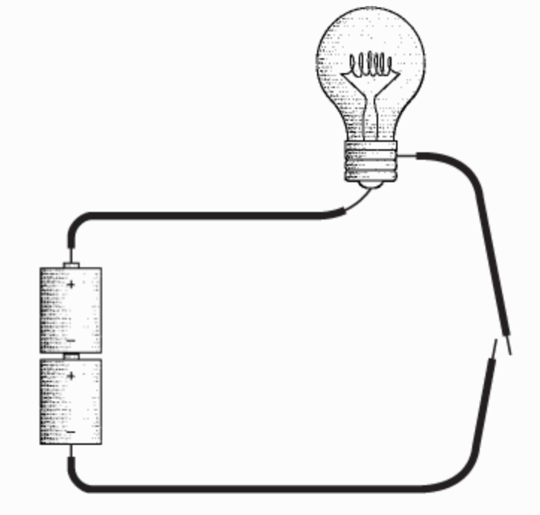Draw a circuit with a wire, a battery, a switch and a light bulb to bring all the concepts we learned from the activity together. Have the students do the same on the worksheet.

To students: In the drawing above, electrons flow from negative to positive.

Big Concept #2: Arduino is just a mini computer

To students: Look at the light blub diagram and can anyone tell me how is this different or the same as a phone power button?

Expected Answer: It is not much different! Pressing the power button on the phone displays the home screen. The only thing different is the phone has a **brain (processor)** and it is doing complex action. For example: pressing the increase volume button increases the volume. Another example: touching the screen displays the home screen. The processor takes an **input** then **outputs** something. So pressing the button is an input and the output is the light glowing or the phone display lighting up. The **ardruino** in front of you is a **brain (processor),** *it takes input and decides what to output.*

To students: Can anyone give me more examples that takes inputs and outputs something in real life?

Expected Answer: Car Meter, Keyboard, Doorbell…

To students: Now we will explore some of the components of the arduino.

Instructor will explain only components needed in this session: 1, 2, 3, 6, 7, 9.

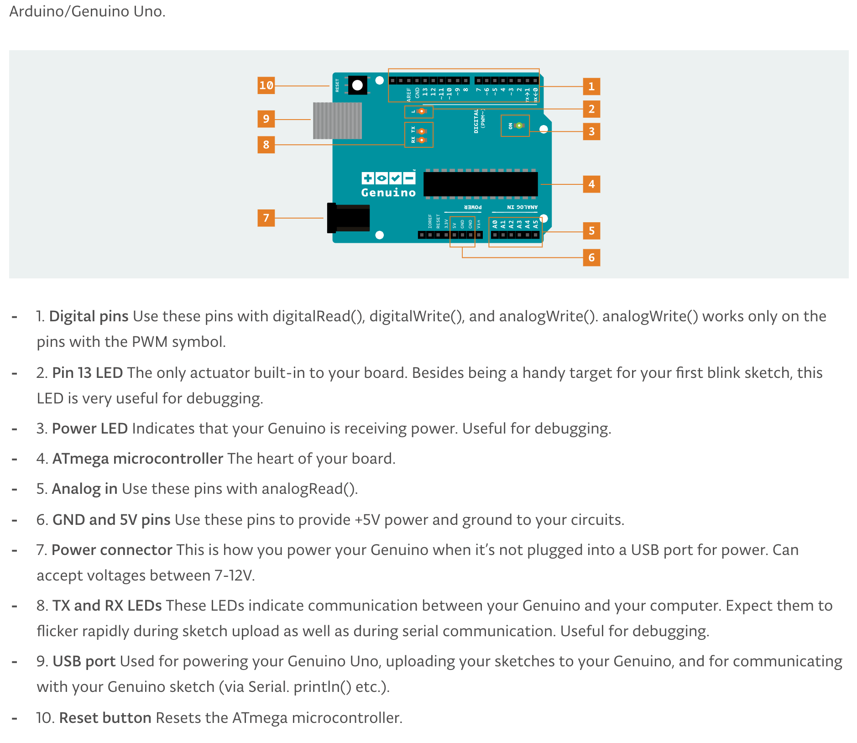

Explain components in this order and have them write down each component on the worksheet.

7. This is where the battery plugs into the arduino board and gets electricity.

3. This light will tell if your arduino is on or off.

1. This is where we are going to put our wires to control the outputs and inputs.

6. This is when we are going to complete our circuit.

9. This is where we get instructions to the arduino to tell it what to do.

2. This is a light you can control right on the board.

Big Concept #3: LED

**Instructor: Draw a LED on the board.**

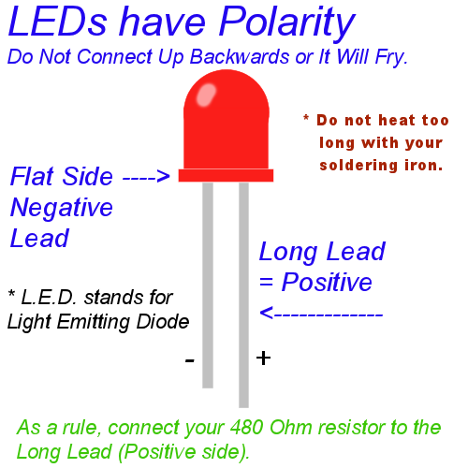

To students: A LED flows in one direction. Positive side wants electrons and negative side wants to give away electrons.

Instructor: Instructor should draw the circuit (see above circuit diagram) on the board. Remind them that the negative side of battery is giving electrons to the positive side of the battery. Have the students draw the LED in the circuit.

To students: Should the long or short side of the LED connect to the negative side of the battery?

Expected Answer: The long side of the LED should connect to the negative side of the battery. The negative side of the battery is giving electrons to the positive/long side of LED.

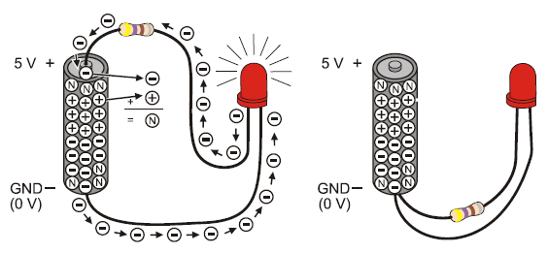

Big Concept #4: Jumper Wire

To students: A Jumper wire connects a circuit. Electrons travel through the jumper wire.

Instructor: Show jumper wires

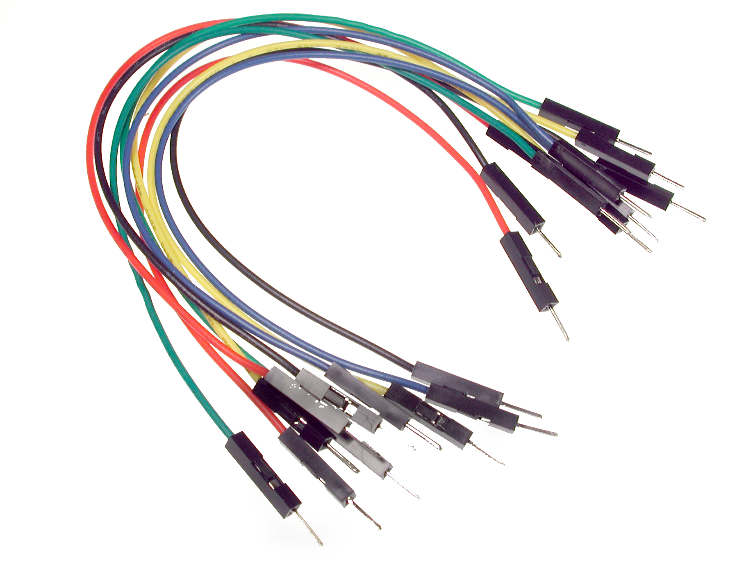

Big Concept #5: Resistor

To students: The purpose of the resistor is *slow down the electrons*.

Instructor: Show a resistor

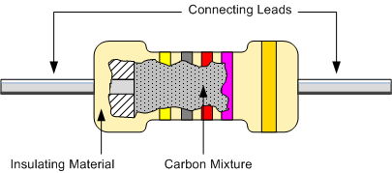

To students: What might happen to the light if we don’t have a resistor?

Expected Answer: The light might burn!

To students: A battery generates lots of electric current, which can burn a led. Wood is a bad conductor of electricity and gold is a good conductor of electricity. A high resistor will light the light.

To students: In the circuit diagram on the board, where should we put this resistor?

Expected Answer: The resistor should go after the negative side of the battery and before the positive side of the led. Have the students draw the resistor (squiggly line) between the battery and LED.

Big Concept #5: Breadboard

To students: A breadboard is used to build circuits so you don't have to tie a lot of wires together. The picture below shows that if you were to provide electricity to one of the dots it will provide electricity to all the dots in green that are connected. So in the middle of breadboard all horizontal dots in one column will have electricity but not the columns next to it unless to connect a wire from one column to the next.

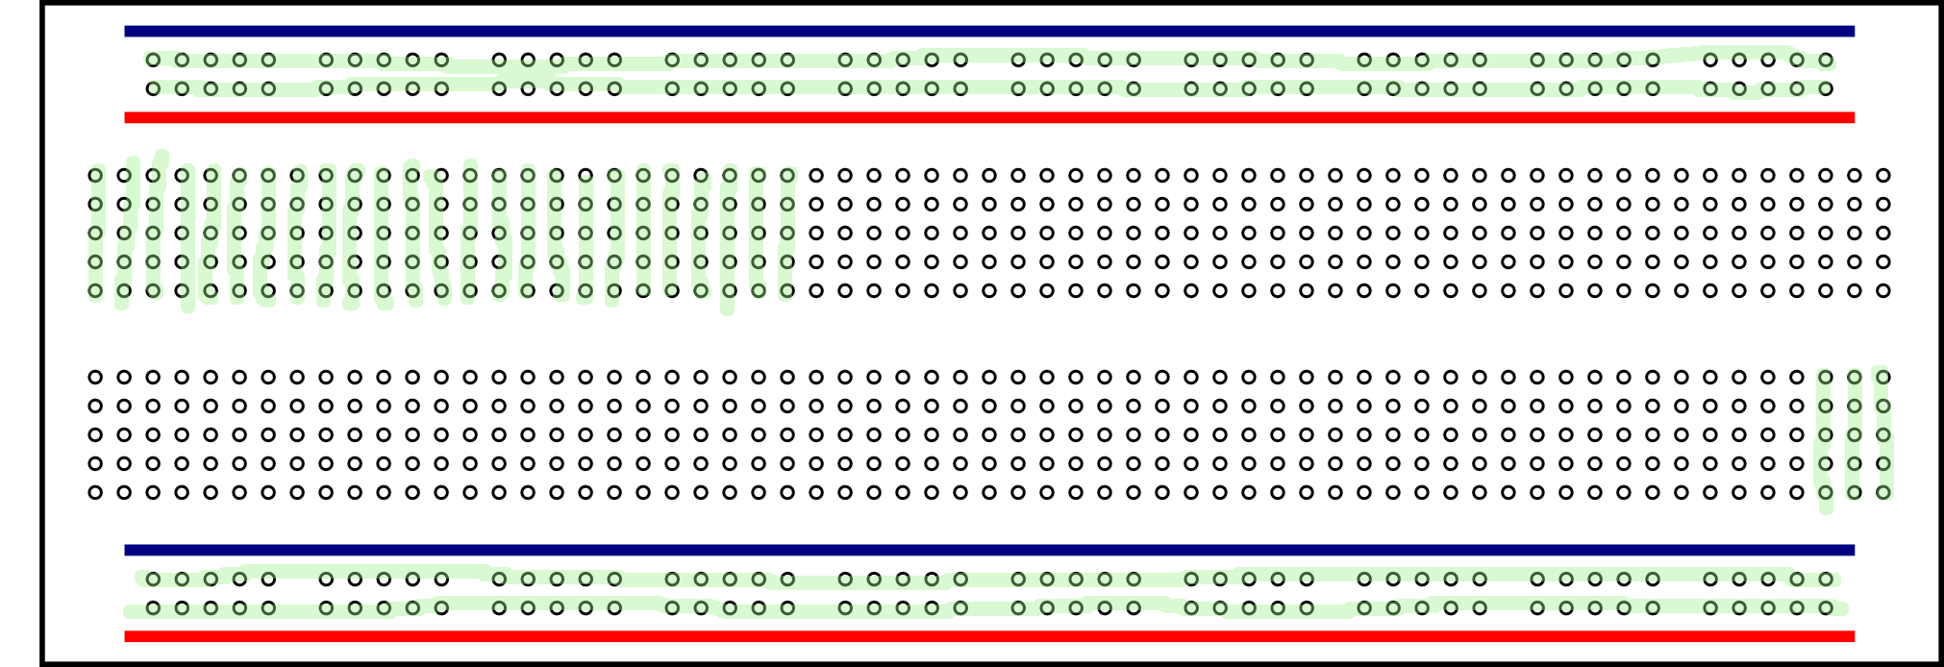

Instructor: Give a few problems on the board on what holes light up base on the wiring of the wires and led.

Activity 2: Wiring a LED

The following code should be downloaded into the student’s arduino:

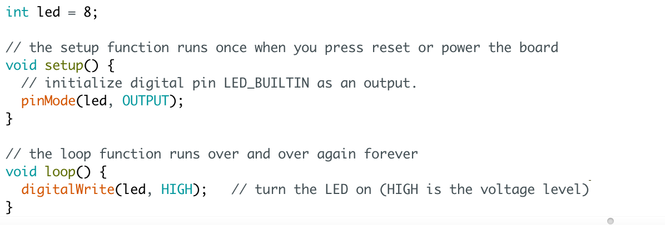

Task:

Pin 8 is outputting electricity.

Pin GND is used to complete the circuit.

Using a LED, a resistor and two wires create a circuit to light up the LED.

Solution:

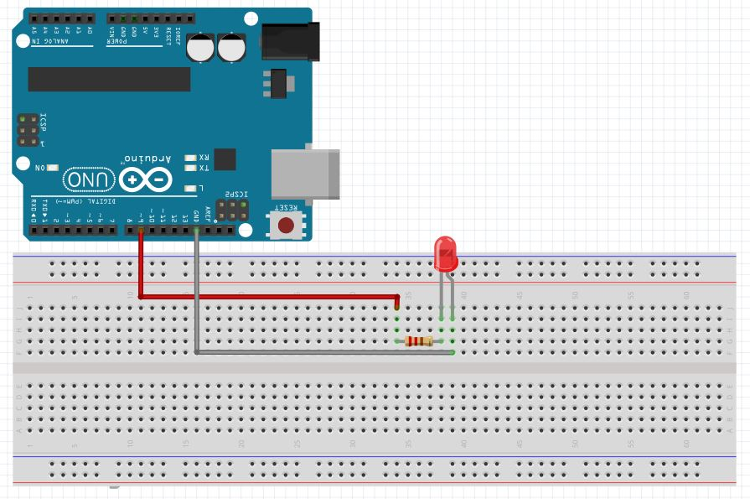

Additional Bonus Tasks:

1. Add more LEDS.
2. Rewire the circuit by crossing over the middle of the breadboard.